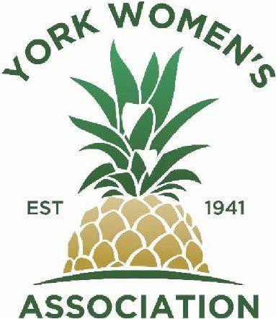
Membership Application
Club Year 2020-2021

PLEASE PRINT LEGIBLY

Date ____________________ Name:

Address:

Home Phone: Cell Phone:

Email: Birth Date (Mo/Day/Year)
How did you hear about the York Women’s Association? (Please circle)

Member Friend Newspaper Flyer Website Facebook Other_____________________________________
Referred By:

The best time to contact me is

Yearly Membership Dues: $35 ($20 for first year if joining January – May)

Make check payable to “York Women’s Association”

Return this Membership Application & dues to:

York Women’s Association, 5 South Broad Street #493, New Freedom, PA 17349

Contact katem413@gmail.com with questions about membership.

We will be in touch with you soon. Thank you, and WELCOME!

